**HOTEL BOOKING ANALYSIS**

**EDA PROJECT**

**SUBMITTED BY :**

**MOHD SAIF ,DATA SCIENCE TRAINEE**

**ALMABETTER.**

**INTRODUCTION:**

**This data set contains booking information for a city hotel and a resort hotel and includes information such as when the booking was made, length of stay, the number of adults, children, and/or babies, and the number of available parking spaces, among other things.**

**We will perform exploratory data analysis with python to get insight from the data.**

# **We will try to answer the following Questions**

1. **How Many Booking Were Cancelled?**
2. **What is the booking ratio between Resort Hotel and City Hotel?**
3. **What is the percentage of booking for each year?**
4. **Which is the busiest month for hotels?**
5. **From which country most guests come?**

**#country wise guests guests=df[df['is_canceled']==0]['country'].value_counts() guests**

**PRT 21071**

**GBR 9676**

**FRA 8481**

**ESP 6391**

**DEU 6069**

**…**

**BHR 1**

**DJI 1**

**MLI 1**

**NPL 1**

**FRO 1**

**Name: country, Length: 165, dtype: int64**

1. **How Long People Stay in the hotel?**
2. **Which was the most booked accommodation type (Single, Couple, Family)?**

**After that, we will make the predictive model to make predictions in the future whether the booking will be canceled or not**

**We will:**

* **Perform the Feature Engineering to make new features**
* **Perform the Feature Selection to select only relevant features**
* **Transform the Data (Categorial to Numerical)**
* **Split the data**
* **Model the data (Fit the Data)**
* **And finally, Evaluate our model**

# **Import Packages**

**First Import necessary packages and import the dataset**

**Now import and display the dataset**

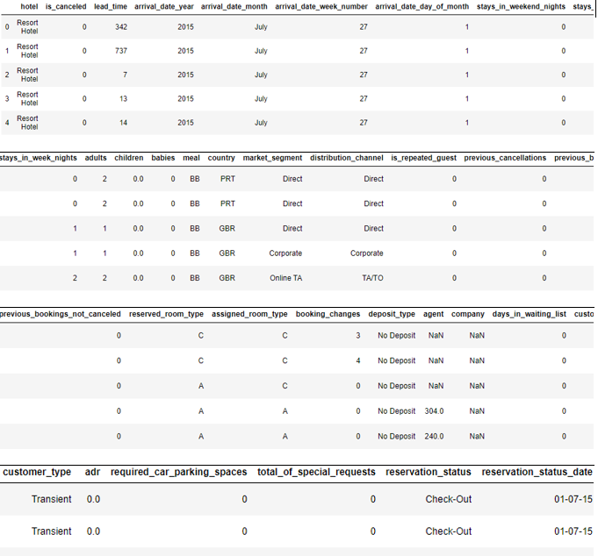

**View of our dataset**

# **Data Preprocessing**

**First copy the dataset, so our original dataset remains unchanged**

## **1. Dealing with Missing Values**

**Check if our data contains any missing values**

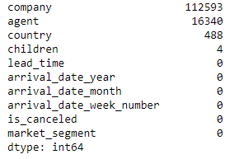

**Missing Values**

**We have 4 features with missing values.**

**WE REPLACE 3 COLUMNS WITH 0 AND DROP ONE COLUMN i.e company.**

**Then we proceed further with the following analysis.**

* **YEAR WISE COMPARISON OF HOTEL BOOKINGS.**

Al YEAR WISE COMPARISON

City hotel=66.45%

Resort hotel=33.55%

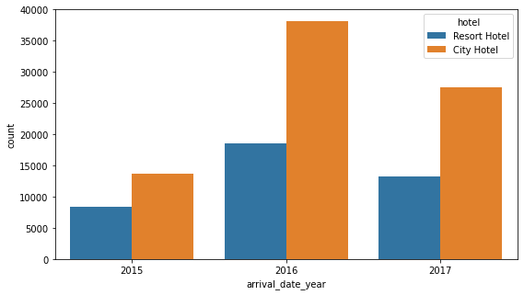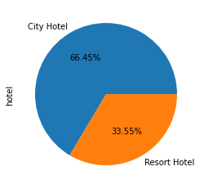HOTELWISE STAY

* **MONTH WISE COMPARISON OF HOTEL BOOKING, CANCELLATIONS,BABIES AS GUEST.**

Al

MONTH WISE COMPARISON

August has most bookings.

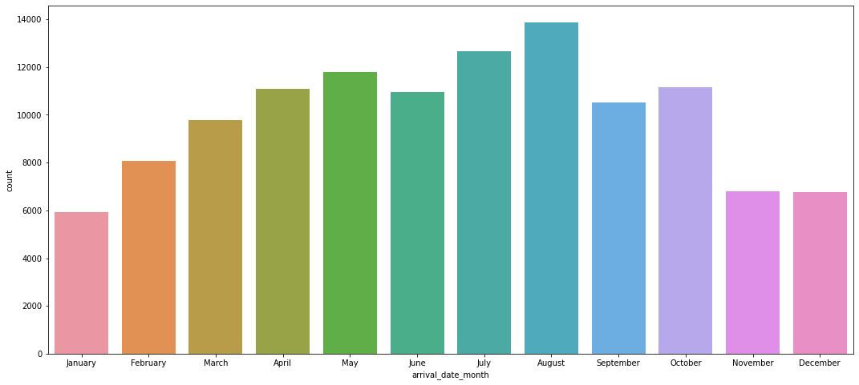

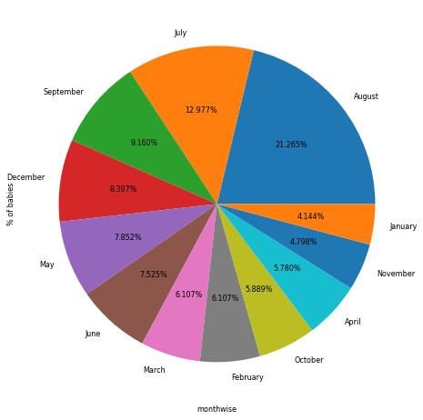Al

GUESTS WITH BABIES

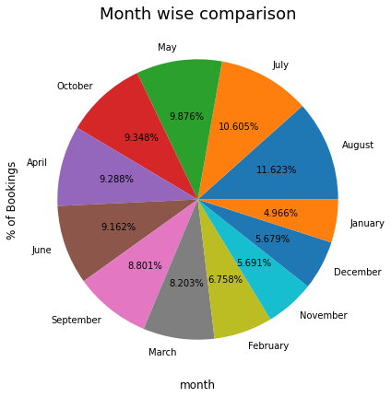%OF BOOKINGS

Al

HOTEL WISE CANCELLATIONS

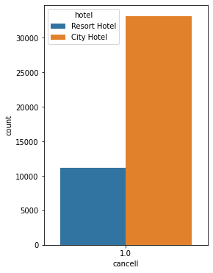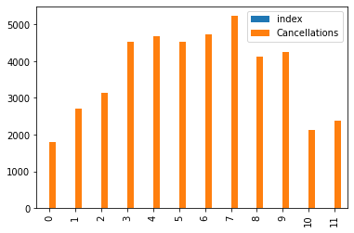CANCELLATIONS MONTH WISE

* **TOTAL NUMBER OF SPECIAL REQUESTS HOTEL WISE , MONTH WISE.**

Al

MONTHWISE REQUESTS

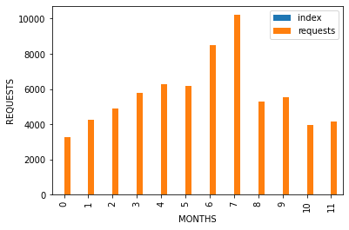

* **NIGHT STAYS ANALYSIS ,SHORT AND LONG STAYS.**

NIGHT STAYS

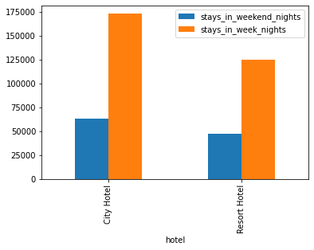

* **BOOKING TYPE ANALYSIS.**

Al

MARKET SEGMENT ANALYSIS HOTELWISE

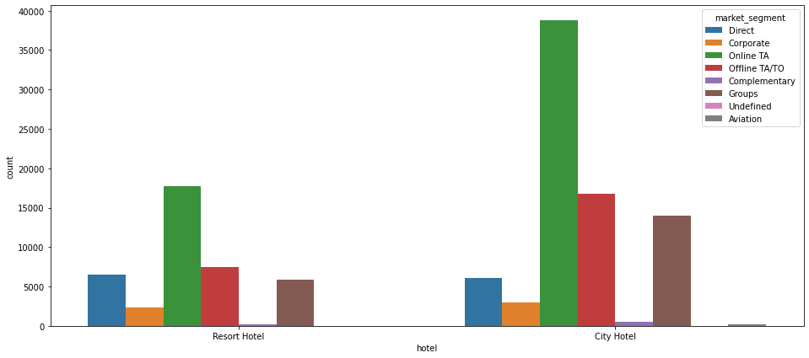

**CONCLUSIONS**

* CITY HOTELS have more bookings(66.45%)
* 2016 has most number of bookings(47.5%), which went down to 34.1% in the year 2017
* The month of August has most number of guests 11.62% , the second quarter Q2 and the third quarter Q3 has most number of bookings.
* Most guests are from Portugal and then from United Kingdom.
* City hotels has more cancellations.
* Most cancellations take place in the second and third quarters.
* Q3 has most number of babies among guests.
* Repeated guests percentage is more for City Hotel,most of them are transient types.
* The month of January , february and march i.e. Q1 has most numbers of repeated guests.
* City Hotels accommodate more guests who stay for week nights.
* City Hotels have crowd that is from working class and business trips as they are staying week nights,and for shorter durations.
* For longer stays (i.e. days>6) people tend to prefer Resort hotels, For Short stay people choose City Hotel.
* Online Booking is the biggest medium of Hotel Booking.
* Most number of special requests are in month of July and August. Number of special requests for City Hotel is higher than Resort Hotel.

**SUGGESTIONS**

* During Q3 Hotels should arrange for a doctor and baby care items for better service.
* In Q2 and Q3 the bookings are the most,therefore staff should be in full strength in these quarters.
* Hotels can put forward some discount offers in Q1 and Q4 as Bookings rate is less.
* In Q3 hotels can hire part time or contract based staff as the rush is more in this quarter.
* Hotels can promote their business online via social media channels and hiring influencers as most of the Bookings are coming from online portals.
* Repeated guests should be given a priority pass or made the member of some of priority group with perks , to retain them. Since they are mostly in Q1 which is winters , they can be given complementary hot drinks.
* City Hotel should give concessions for people staying for more than 6 days.
* Resort hotels can give complimentary gift and services (like free cabs,etc) for boosting the short stays.

**RESOURCES USED:**

**KAGGLE**

**ANALYTICS VIDHYA**